**Oct/Nov 2011 (9231/13)**

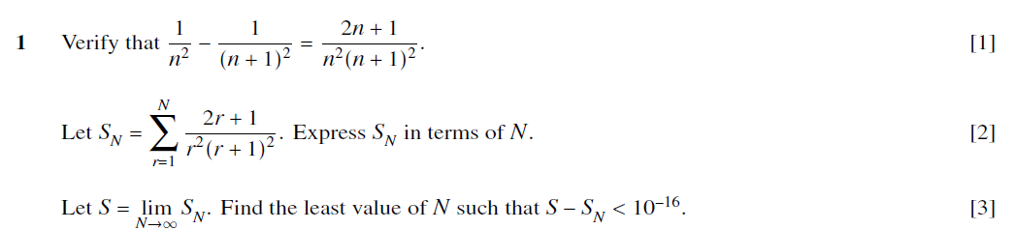

**May/June 2011 (9231/11)**

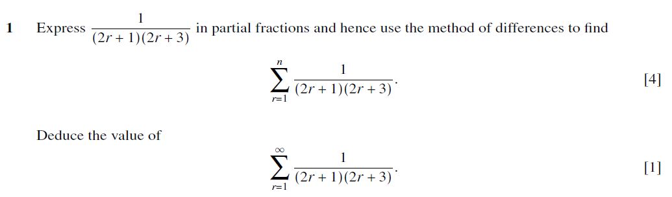

**May/June 2011 (9231/13)**

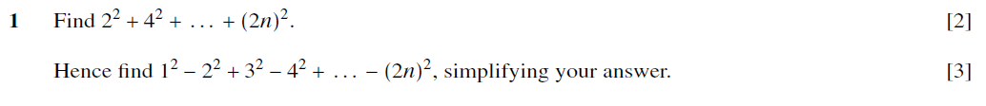

**Oct/Nov 2010**

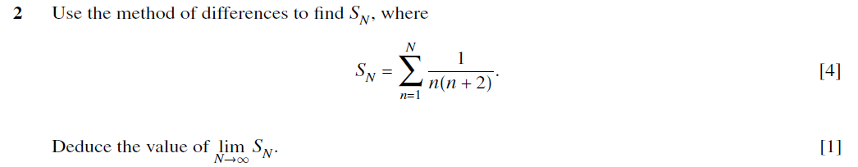

**May/June 2010 (9231/11&12)**

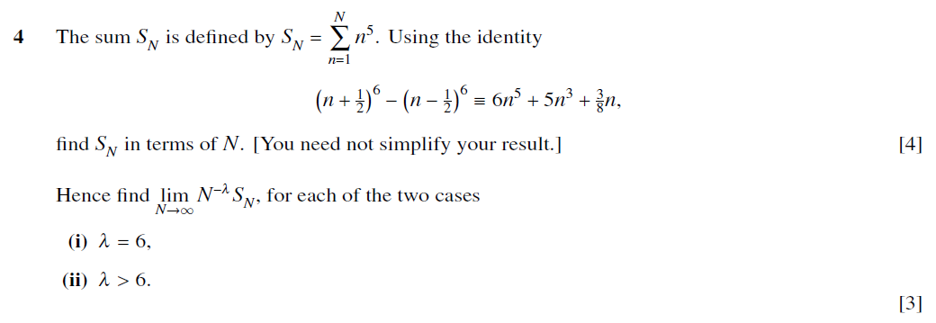

**May/June 2010 (9231/13)**

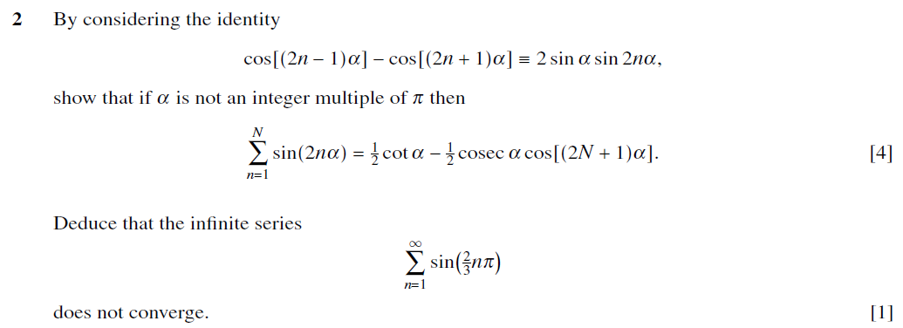

**May/June 2009**

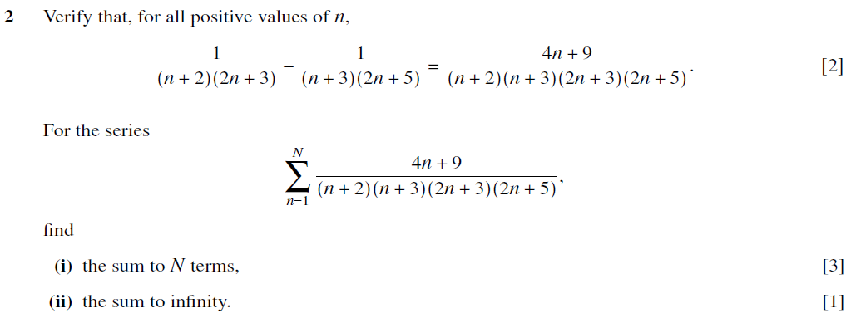

**May/June 2008**

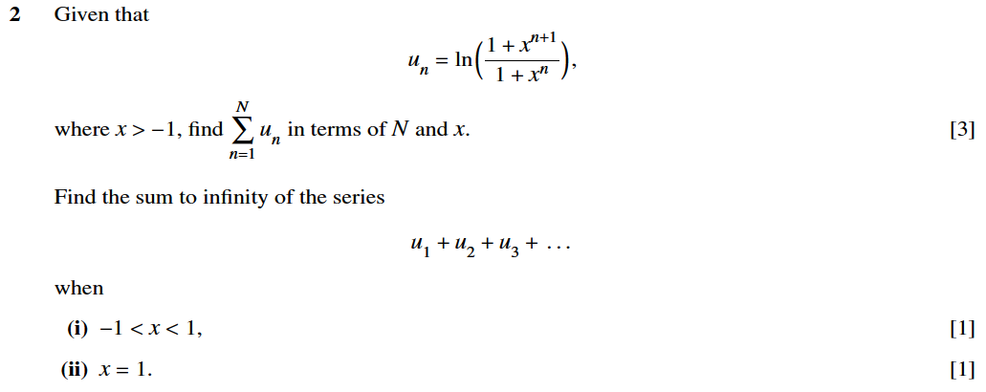

**Oct/Nov 2007**

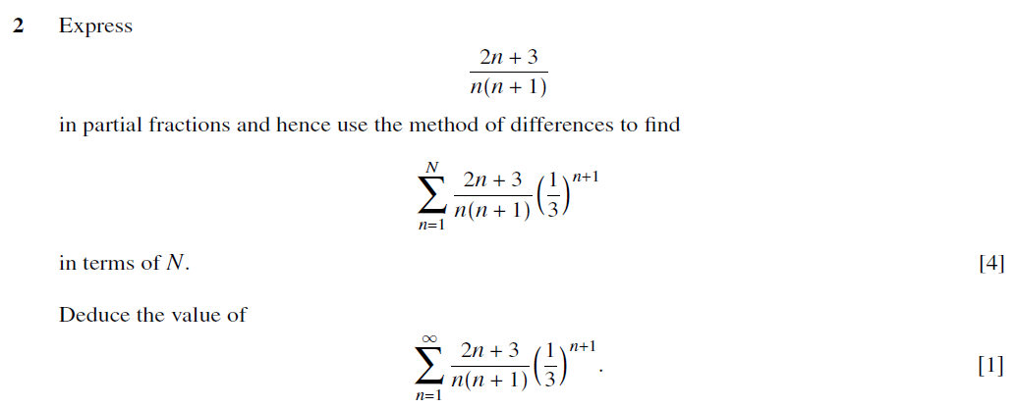

**May/June 2007**

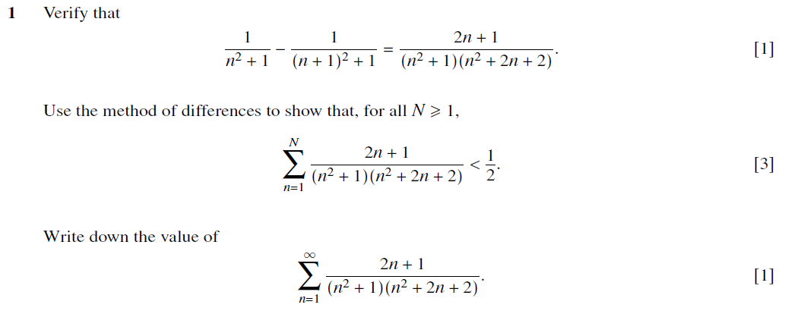

**Oct/Nov 2006**

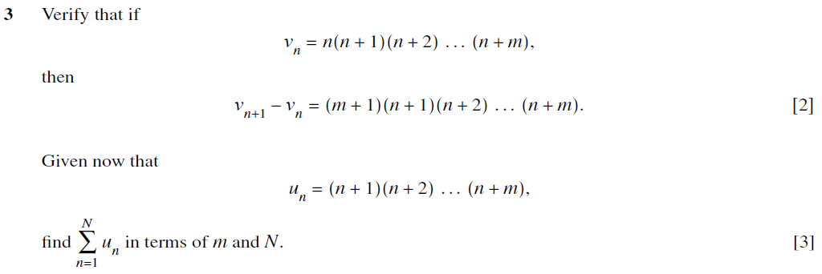

**May/June 2006**

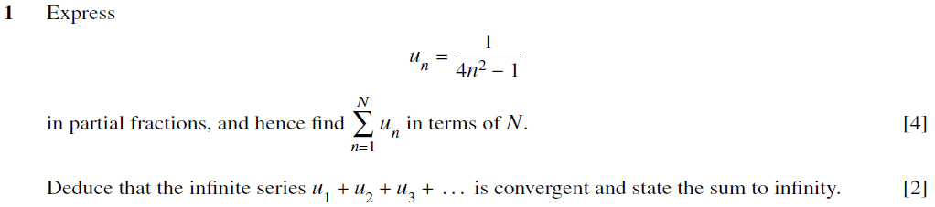

**Oct/Nov 2005**

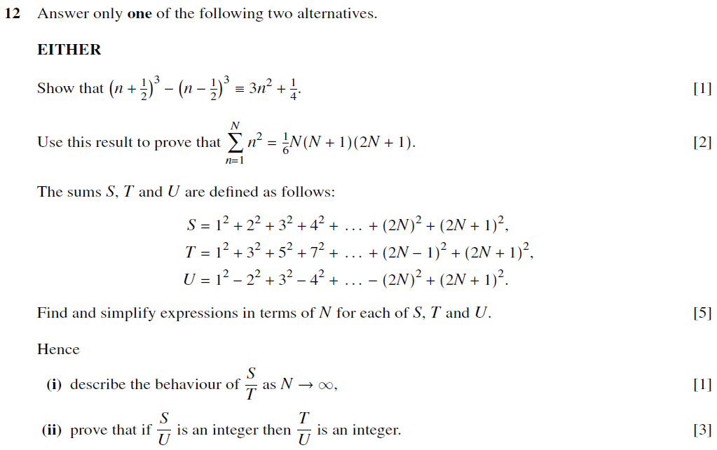

**May/June 2005**

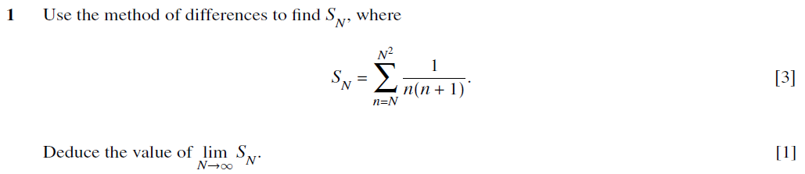

**Oct/Nov 2004**

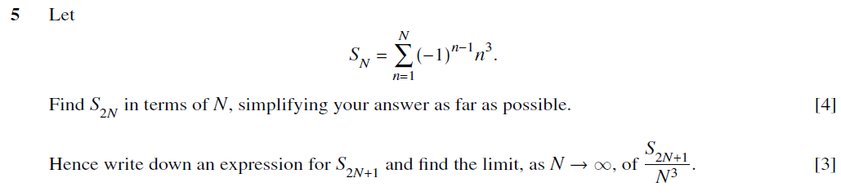

**May/June 2004**

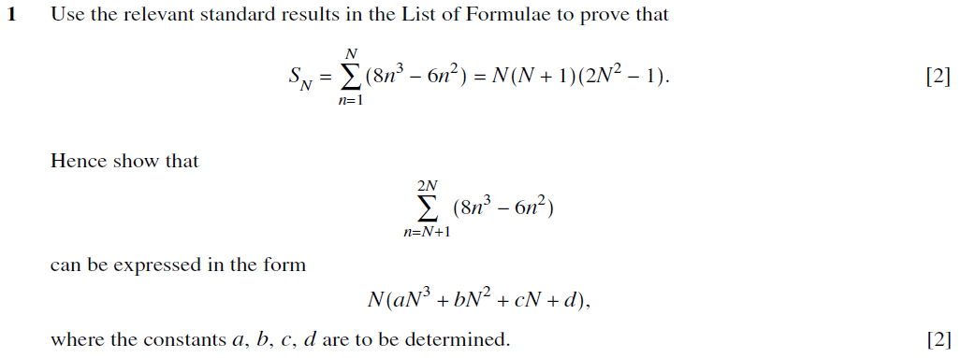

**Oct/Nov 2003**

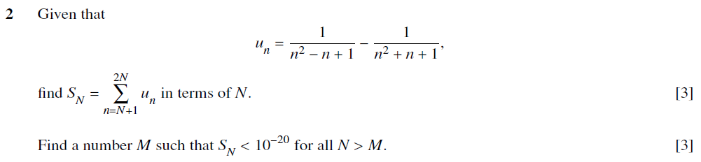

**May/June 2003**

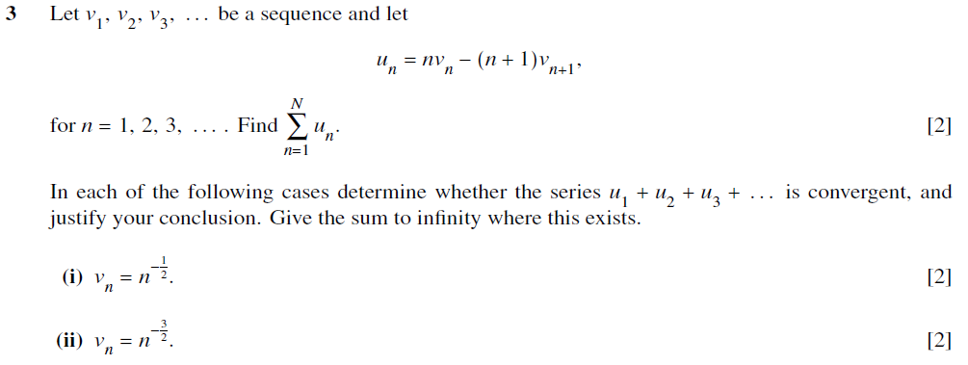

**Oct/Nov 2002**

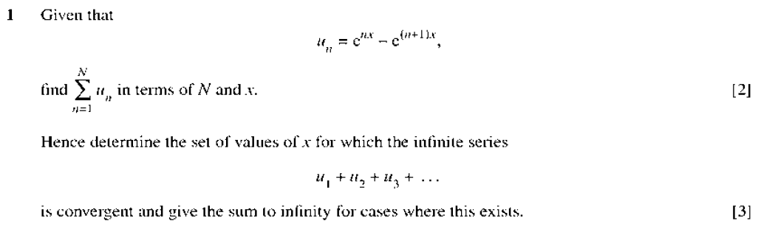

**May/June 2002**

